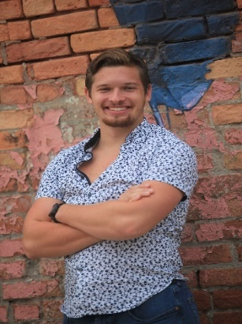
Hello there!
I am so happy to be writing to you today. God has taken me on a rollercoaster of a life over the past few years, especially most recently this past year. A lot of change has come very quickly and as I continue to humble myself before the power of the Holy Spirit, He takes me to unexpected new places I never saw myself to be at.
During my senior year of high school two and a half years ago I thought I had life figured out. I was confident in what major I was going to pick, excited with what the future had in store, and feeling confident in my relationship with the Lord. Then in February my father passed away unexpectedly. This was an absolute shock to my family and is something we are still processing to this day. But God has used it for His good in so many ways in shaping me into who I am today.
Through many major changes while in college at the University of Toledo, making new friendships, and lots of time in ministry through Cru and Cedar Creek God has shown me so many new things about myself and brought me to where I am today. It was on my summer mission to Orlando working at Walt Disney World ministering to college and international students last summer that I felt the calling on my life to full time ministry. It has been a wild ride getting here but I am so happy for where God is taking me. I feel like the internship program at Cedar Creek Church is the next step in that journey.
Starting in August I will be the Next Steps intern at the Oregon campus of Cedar Creek. I am so excited to see what this next step in life has in store for me. In this role I will be working with people in the church in taking their next steps in their faith journey. Helping them to grow in their faith and build community centered around Christ. These are some of my biggest passions in life and I am so excited for this opportunity to serve the church in this way and see how the Lord uses me over this next year.
I would love for you to join my support team as I go along this journey. I can use prayer in support and encouragement along with financially. You can give by sending a check to this address or go to cedarcreek.tv/internship and find my name to give digitally. You can give one time or monthly. If you would like to contact me to hear more you can reach me at noah.hagedorn14@gmail.com or 419-367-3761. I am so excited to see what God has in store and share with you all about it!
God Bless, Noah Hagedorn

