LivingItOut Podcast
October 2019

Current Reality:
At this time, we are producing a weekly video unpacking the weekend message’s key takeaways and next steps.
- The Target Audience is Groups.
  - The purpose of this video is to lead a group of people through a discussion about the weekend messages’ key takeaways and point them to next steps.
  - Questions are offered for Groups to discuss during their Group time.
  - Individuals can use this resource on their own.
- It is currently called, “The Message Discussion Video.”
- Current delivery: Video is posted on website, app and through Right Now Media; audio is posted as a podcast through iTunes and LIO subscribers.

Proposal:
Continue producing weekly content (that follows the weekend content, offers next steps and discussion questions in both video and audio format) with 4 key shifts:
- Change the target audience from Groups to individuals.
  - The purpose would now be to provide an experience during the week where individual guests can connect with principles from the weekend message and be challenged to live out the principles by taking a next step.
  - Groups can still use this resource for their group discussion.
- Change the name to the “LivingItOut Podcast” or similarly to the LIO devotional, move the name to CedarCreek branding
- Change the experience to a focus on authentic conversation that invites the listener in to what it means to live out the weekend principles and key takeaways.
- Change the branding and the way we promote it by focusing on as a resource for the individual guest.
  - Have regular hosts with guests. One of the keys to connecting with guests is to have regular hosts that listeners can connect with. The recommendation would be to have two hosts that are always on with the option of bringing in a guest. The guest could be the weekend communicator or someone the hosts choose to add to the conversation.
    - Host Recommendations: Each week will have 2 regular hosts. We recommend keeping the pool of regular hosts to 3 individuals.
- Move release to Wednesday morning, after the weekend service. Currently releases on Saturday before the service.
- Move Video Recording time to Mondays at 2pm.

Problem Trying to Solve:
- Engagement. Out of the current 300+ registered Groups, 39 have shared that they are discussing the weekend message in their groups. Out of those 39, we are not sure how many are using the Discussion Video.
  - Currently we have 305 groups. If the average groups size was 10 individuals (this is generous) that would be a total target audience of 3,050 individuals. By creating a resource designed for the Group experience and not the individual experience, we are potentially missing the opportunity to connect with thousands of guests that do not participate in a group, and specifically in a group that uses the discussion video.

If this proposal is accepted, below is the vision, the goals of the experience, steps to transition, FAQs, and some future dreaming:

New Vision:
The LivingItOut Podcast will provide a weekly resource that helps our guests engage with our church. The podcast will encourage listeners to live out the weekend message through discussion on its key takeaways and principles. It supports the weekend service messaging and is part of our strategy to help people Know God. Through authentic conversation, hosts will guide listeners to take steps on their spiritual journey. This podcast will also be a place to share news about events and happenings in the church, and to celebrate stories of life change.

Descriptions of New Experience:
- A podcast will be made each week to discuss the weekend message, serving as a reminder to guests of the bottom line, key takeaways, and next steps.
  - Length: 15-25 minutes long.
  - Production: Created with the listening audience in mind but also made available to watch.
- Regular Hosts: Each week will have 2 regular hosts. We recommend keeping the pool of regular hosts to 3 individuals.
  - Key Elements of each podcast:
    - Authentic Conversation about the weekend message
    - Questions for reflection and/or discussion offered throughout with no pause of breaks in discussion.
    - Positive Story Telling – Stories of Life Change told here
    - Next steps across the church

Transitioning - Steps:
When looking at both the current discussion video format and the potential podcast format they and made up of: audience, content, format (how we deliver content), production, systems for delivery, branding and promotion. Not all changes need to be implemented at once.

Below are our recommendations:

- Audience: Change Target – January 1
- Content: Remains the same still coming from the weekend service.
- Format: Changes starting January 1. This would include having 2 regular host with a guest host, no pauses for questions and the move to authentic conversation.
- Production: Production remain the same for now with video/audio taping.
- Systems for delivery/distribution: Continue delivering as a video and podcast. Video would be in same ways (through RNM, Web, App) and podcast through iTunes and LIO subscribers. We would ask Arts to evaluate a refresh our iTunes presence and look into other opportunities to share content through YouTube for now and in the future, iHeart radio, etc.
- Branding and Promotion: For the immediate, the LivingItOut podcast will be shared as a NextStep for adults to take in the area of Knowing God. Both Groups leaders and GrowthTrack hosts will point guests to the podcast as a resource. Also, the LivingItOut Podcast may be shared during a weekend message if it is an appropriate NextStep for guests to take. Social Media is another place that the LivingItOut Podcast can be promoted. We would recommend a branding update and a more regular presence on social media as a next step. We recognize overall promotional strategies are being evaluated and developed and could result in changes to this down the road.

Future Dreaming:
- Develop intro with music and bumper and outro- music with a thanks for joining us and invite to join next week.
- Design a studio for the podcast. To make it a better experience for those listening to the podcast in their cars or through their headphones, we may consider making a more permanent podcasting space equipped with professional podcast mics and soundboard. We would still want to video this so a stationary camera would also be needed. The goal would be to leave the studio set-up for recording and for the producer to be able to run the equipment. Examples of the studio:

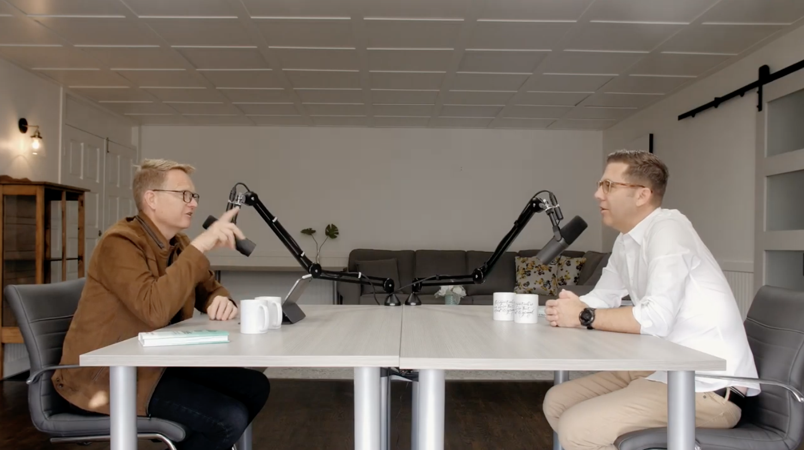

Carey Nieuwhof - Camera with guest
https://www.youtube.com/watch?v=x3cm65yOETg&t=536s

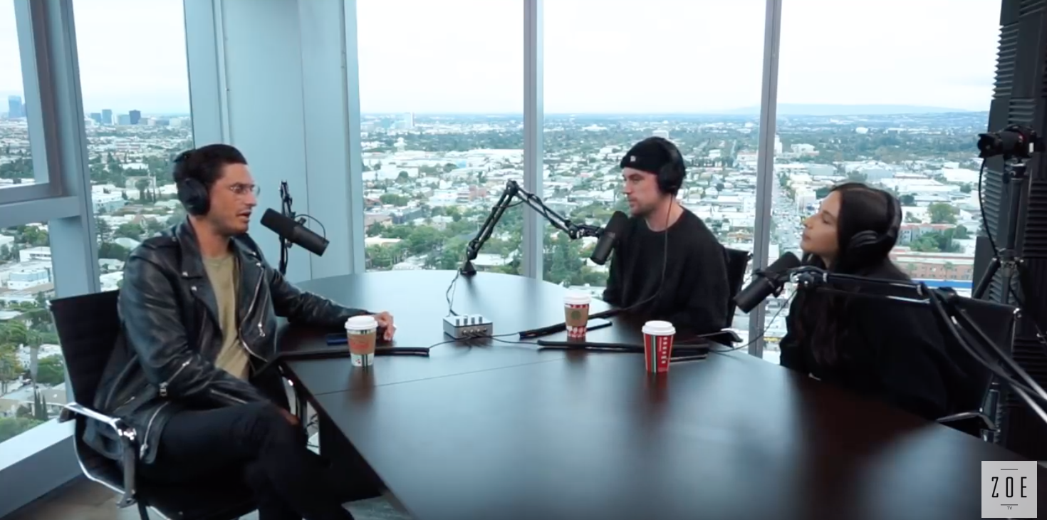
Multiple Host with Cameras
https://www.youtube.com/watch?v=valmwC_Zsso

- Have a producer.
  - Producer: Oversee the production of episodes and pitches in with fresh ideas for the podcasts. Look for guests or influencers who can share their expertise or experiences based on the episode’s topic, provide support to the host and the rest of his team throughout the conceptualization and production process. Oversee recording, editing, and even the publication of each episode.

