Intern Support Raising

Why Support Raising?
As an Intern, we want to increase your opportunity to be accessible and available for ministry opportunities. Though we understand some employment situations provide flexibility that might be appropriate, some of you may need to eliminate your full-time or part-time employment.

How much money will I need to raise?
Each Intern is expected to raise at least $1,000 by June 24, 2023 to officially qualify for the Internship. Those funds will be used to show the intern is committed to the program. Intern payouts will be made in equal amounts (based on remaining balance) following the CedarCreek Payroll Calendar.

The ultimate goal for support raising is to supplement living expenses, which replaces part-time or full-time employment allowing undistracted focus throughout the Internship. The traditional amount is between $5,000-15,000.

Please take a moment to complete the support needed worksheet below:

Worksheet:

- Internship Program Entry Minimum $ 1,000
- Monthly Living Expenses: Calculate the estimated amount needed each month to cover your expenses $
- Multiply the amount on line 2 (above) by 10 (months) to get
the total amount for the term $

Internship Minimum (Line 1) + Total Expenses (Line 3) = TOTAL $

Support raising totals for each intern will vary person to person.

Donating Funds

Currently there are three ways to donate funds to the internship program: online, check, and cash.
Online:
Step 1 - Go to www.cedarcreek.tv/internship
Step 2 - Click the “Donate” button
Step 3 – Select the Year
Step 4 – Select “Participants Name” and select the intern
Step 5 – You’ll then be able to give a one time or recurring gift to the intern of your choice using a credit card or debit card

Check:

Step 1 - Make the check out to “CedarCreek Church”
Step 2 - In the memo write “Internship - Intern’s Name”.
(Note: If the memo is left blank the funds will go into the general fund and not your internship account.)
Step 3 - Put the check into an envelope and drop it into a Giving Box at any CedarCreek Campus
(Or mail checks to 29129 Lime City Rd., Perrysburg OH 43551)
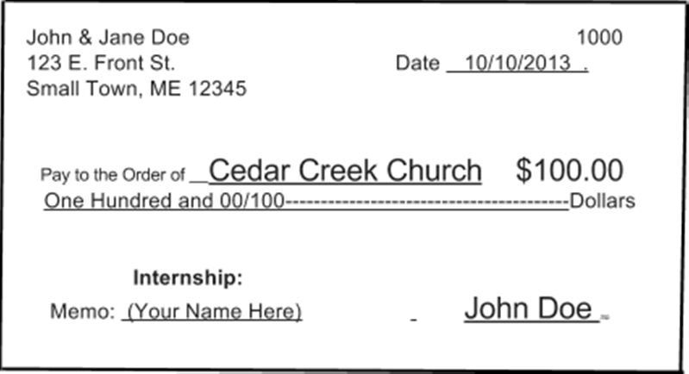

Cash:

Step 1 - Seal the cash into a deposit envelope. Envelopes can be found at all of our campuses
Step 2 - Write the name and address of the person who donated the funds, and the amount on the envelope. In the memo of the envelope write “Internship - Intern’s Name”
(Note: If the memo is left blank the funds will go into the general fund and not your internship account.)
Step 3 - Put the check into an envelope and drop it into a Giving Box at any CedarCreek Campus

Weekly Reports & Fund Distribution
Project Manager of Ministries prepares monthly reports updating the balance of support raised. These reports are provided to the interns and the internship director via email.
It is the intern’s responsibility to communicate the updated support raising information to the supervisor and the Intern Team.

The intern will be able to view a list of people who donated to your internship account from the external view of the fundraising group. The monthly report will include a cumulative report list of all contributions.

Intern Payouts will start August 14th 2020 and will be made in equal amounts (based on remaining balance) following the CedarCreek Payroll Calendar.

The amount paid out will include a 7.65% (for church taxes) deduction from your account.
Example: Payout of $100, deduction of $107.65

My Account and Surplus Funds Agreement

I understand and agree to the following:

Any and all money I raise are designated for the CedarCreek Internship Program. According to the IRS, authority over contributions is transferred when it is received by CedarCreek; thus, no amount may be refunded to the donor. If I do not participate in or I drop out of the Internship Program for any reason (illness, family emergency, lack of timely support raising, etc.), the funds will be utilized for Program related expenses and cannot be reimbursed to me or my donors.

My financial support will be administered through the church (CedarCreek) and distributed as a taxed salary. In the event that I do not complete the term, I will notify all of my supporters. Any funds remaining in my account will go into a general account to be used at the discretion of CedarCreek church.

Signature: Date:

Copy for CedarCreek

