Dear,
The room was dark and full of people, all had heads bowed and my eyes were filled with tears. The message had been about following the will God has for you and the question had been asked if you’re willing to go and do whatever God calls you to, raise your hand. I held my hand high, not knowing where I was going to go or what it would look like.
Back in 2010, my fiancé Tom and I started looking for a church we could both grow and learn in. We drove up to CedarCreek Church in Perrysburg and instantly fell in love. We had found somewhere we could grow, learn and become passionate for Jesus. Fast forward to 2013 and our lives looked a little different. We had gotten married, bought a house and had a baby girl, Ava Grace. In this stage of our life we felt God in ways we haven’t felt previously. We knew we needed to get placed in a church and call it home at this point in our lives.
In December 2013, we heard the news we had been waiting years to hear, CedarCreek Church was opening in Findlay in the fall. We couldn’t wait to get involved and learn what it was like to be in community with other Christians who we could do life with. When the campus opened my husband joined the security team and I went to try out Cedarville, the children’s ministry. Little did I know I would fall in love. I have always love children, but teaching them about Jesus was more fulfilling than anything I had ever done. I began volunteering every week at multiple services. This lead to the opportunity to teach our preschool large program, the lesson where we teach them how to worship, give offering, hear a true story from the Bible and how that lesson applies to our lives.
I felt the call to ministry in early spring of this year. After several weeks of praying about it and a couple subtle nudges from God, I applied for the internship at CedarCreek Church. It is with great joy to share that I have been accepted, with Cedarville as my ministry focus. This is a one year internship program where I will learn from the best teaching these children from babies through fifth grade how to love Jesus, serve others and tell the world about Christ. The program is 30 hours a week including 5 weekend service experiences. I also have the privilege of learning with other interns, hearing from influential leaders and continuing to grow the skill set that God has given me.
I am in the process of building my support team which includes prayer, encouragement, and financial support. My goal for this is to be able to resign from my full time position as a daycare preschool teacher to dive into this experience with full devotion. This financial support can be given through a one-time or monthly donation that is tax deductible. This will allow my family and I to make a lasting impact to help expand the kingdom of God.
I feel blessed and honored if you would prayerfully consider joining my support team as I move forward into the next steps. Partnering together, we can make an eternal footprint for the kingdom of God as I help young children encounter a relationship with Jesus. I look forward to following up with you in the next week to talk to you more about details and potentially set up a coffee date where I can share more of my vision with you and answer any questions. Please feel free to contact me at any time to discuss this exciting partnership!
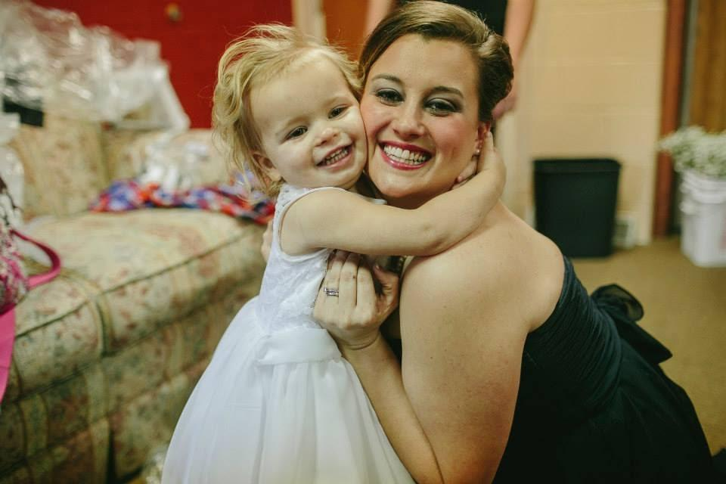
Thank you and May God bless you!
Jaime Shank
jshanker861@gmail.com
419.788.9526

