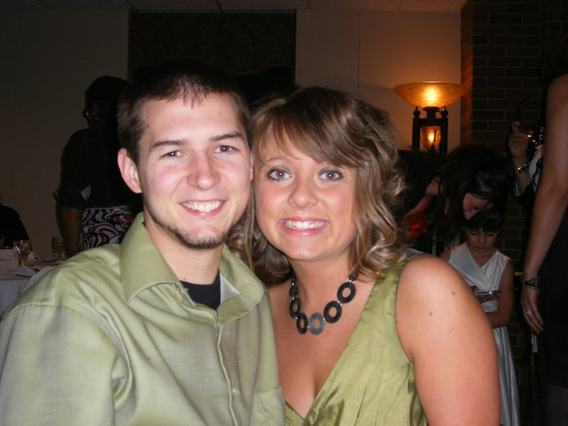
Greetings,
I am writing this to you because God has blessed me with an amazing opportunity. Since marrying my beautiful wife Keshia and moving to Toledo, Ohio we have been attending CedarCreek Church. During our time here I have been volunteering in the student ministries. Specifically in our Middle School programs we call Fusion. Fusion is designed to help students connect with other student with the same beliefs, connect with leaders, and most importantly connect with Jesus. We have our services that take place during each of our five weekend services. We also have life groups that meet on Thursday nights. We play games, hangout, and dive into God’s Word and what it means in our lives. It is truly awesome to see God work in the lives of students on a weekly basis. He is always moving around us and it is a great privilege to align ourselves with Him.
I am excited to say that I have been accepted into the internship program here at CedarCreek. My internship will be focused on Student Ministries, including Fusion and our high school programs called Vertical. I will be helping to plan events, lead volunteers, as well as teaching and connecting with students. I will also be participating in theological and leadership classes with other interns in the CedarCreek internship program. This is going to be an incredible period of growth and ministry and I am very excited about this opportunity.
We are extremely excited about what God has for us in the next year. I currently am working full-time at Starbucks while my wife Keshia is finishing her masters of counseling at the University of Toledo. She will be completing her degree this spring, and will continue to use her God given gifts. As we both continue to follow God’s call for our lives we ask that you prayerfully consider joining our support team. This goes way beyond the financial aspect. We are going to need constant prayer and encouragement throughout this entire year. The fact is that we do also need financial support. In order to participate in this opportunity I will move to part-time at Starbucks, meaning we will need some financial support. This can be a one-time gift or regular monthly pledges. These financial gifts are tax deductable and will go a long way in supporting both Keshia and myself and the lives we hope to impact. My internship will last one year and if you choose to support monthly, your commitment would last for that year. Please consider supporting, either in your prayers and/or financially as we move forward with this next stage of our lives. I will be contacting you shortly to go over more of the details. If you have any questions, you can reach me by email at Brandon.Maybee@gmail.com or by calling/texting my cell phone at (517)-990-7364. Thank you so much, God bless!
Sincerely,

Brandon Maybee

